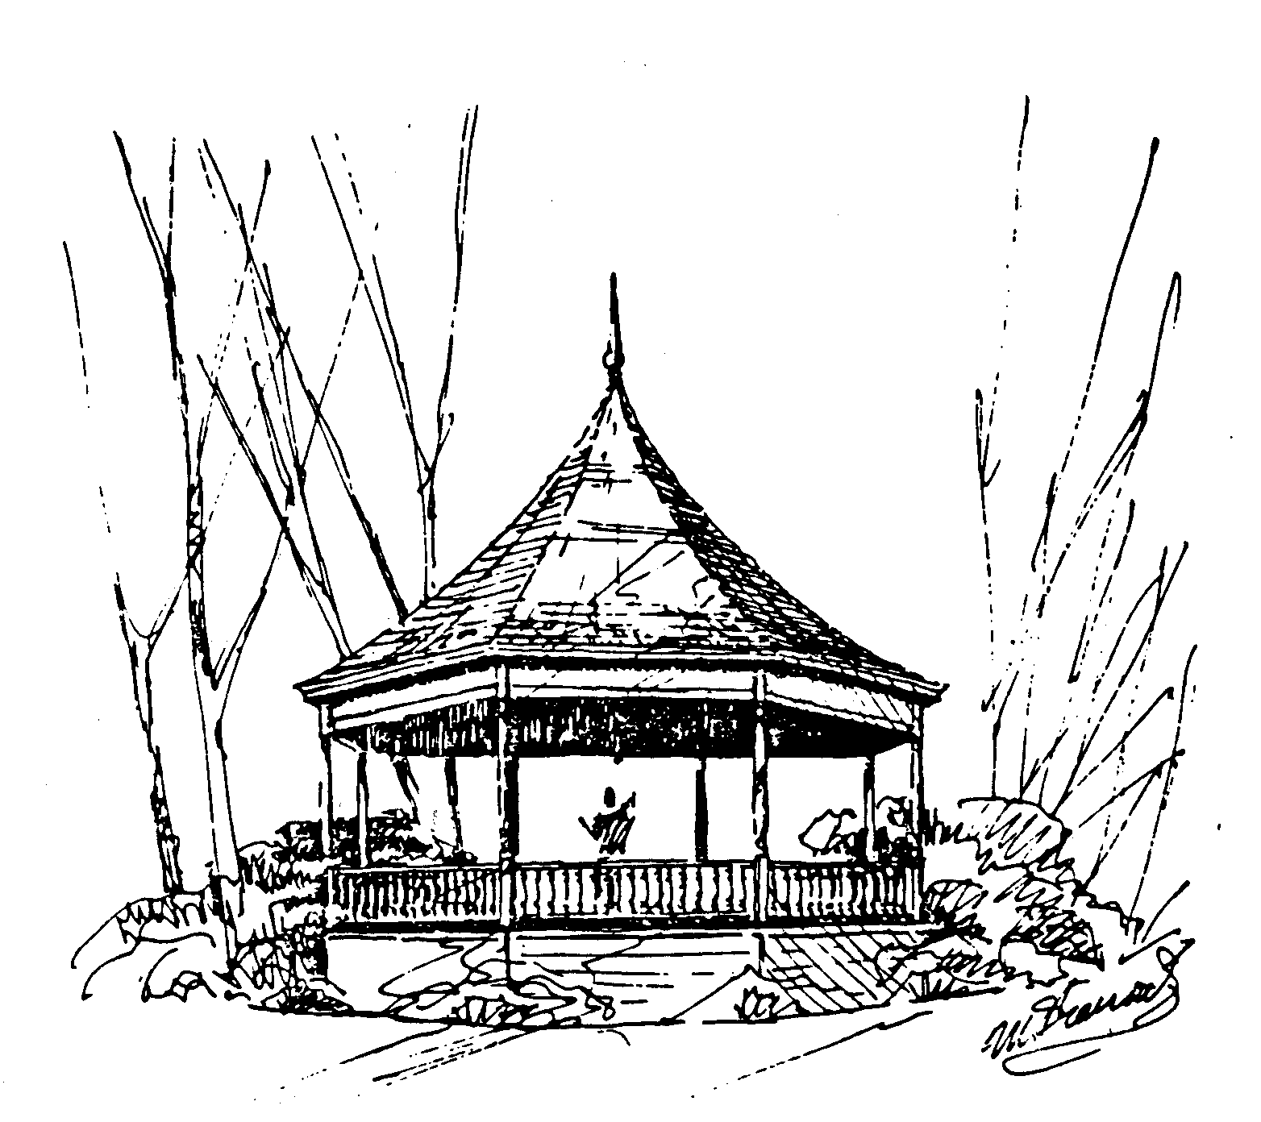
PO Box 173
Lexington, MA 02420
Date
´ADDRESSª
´SALUTEª

Summer is nearly here and once again the Lexington Bicentennial Band presents a weekly outdoor concert series on the Hastings Park Bandstand. We also play two indoor concerts during winter and spring at Lexington High School.

These entertaining concerts are free and are very well attended by the public. We believe our band has become a highly visible and important cultural asset to the Lexington community.

In order to make these concerts possible we rely in large part on corporate sponsorship. The money raised goes primarily to pay our Musical Directors (Jeff Leonard, the Band Director at Lexington High School, Al Dentino, the band director at Concord-Carlisle High School), to purchase new music, and to print programs. Although we are able to share some facilities with the Town of Lexington, the Town does not contribute to our support. All the musicians donate their time and talent.

We invite you to contribute a fully sponsored amount of $250. However, we hope you will contribute in greater or lesser amounts as you are able. Each sponsor is listed in our programs each week in summer and in our winter and spring programs as well. Announcements are made at each concert drawing further attention to our sponsors. Additionally, sponsors are listed on our Web site, www.lexbicband.org. If your organization has a Web site, we also provide links to you from our site. If you can help us, we enclose a form which you can use for your tax deductible donation.

Even if you can not contribute this year, please join our audience at the bandstand for a series of lively musical summer evenings. Our first concert is ????? at 7:15 PM. We perform at the same time every Tuesday during the summer, weather permitting.

Thank you,
We would appreciate your response as soon as possible so we can include your listing in all the programs this summer.

